**When there is GAP in Standby that can’t be resolved. We tried to restore, but logs would not apply and also Archivelog backups on Primary would not delete logs that were not shipped yet. Somehow Primary did not think those logs were shipped. However, we saw that logs were already on Standby side. That did not make sense.**

**From Standby on NodeA to determine a gap**

select * from v$archive_gap;

**From Primary to restore**

rmanc

restore archivelog sequence between xxx and xxx;

alter system switch logfile;

**##Archivelog backups produced following warnings when tried to delete them.**

**RMAN-08137: warning: archived log not deleted, needed for standby or upstream capture process**

**##As result +FLASH_01 was getting full and we had to temporary redirect logs to +DATA_01**

**ALTER SYSTEM SET log_archive_dest_1='location=+DATA_01';**

**# to put back later on when issue resolved.**

**ALTER SYSTEM SET log_archive_dest_1='location=+FLASH_01';**

**## How to remove Standby database from broker configuration.**

**From Primary**

dgmgrl /

**remove database ‘HEPYPRD_xhepydbw2pcl’;**

show configuration;

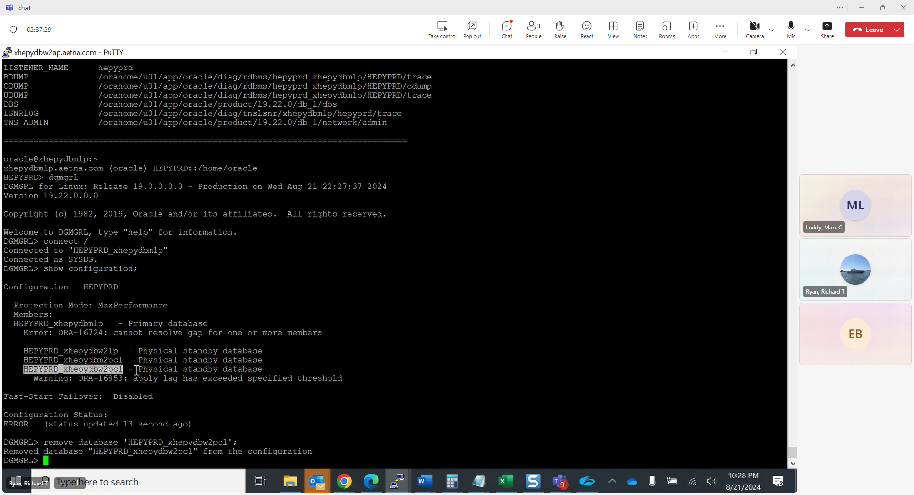

**# Below commands and screen example how to disable standby database from broker configuration**

dgmgrl /

disable database 'HEPYPRD_xhepydbw2pcl';

show configuration;

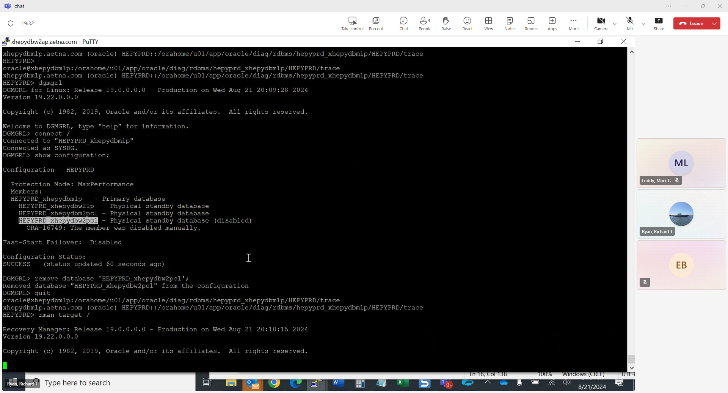

**# Below screen examples and below actual command how to remove/purge/delete archivelogs in case space need to be cleared**

**rmanc**

**delete archivelog all;**

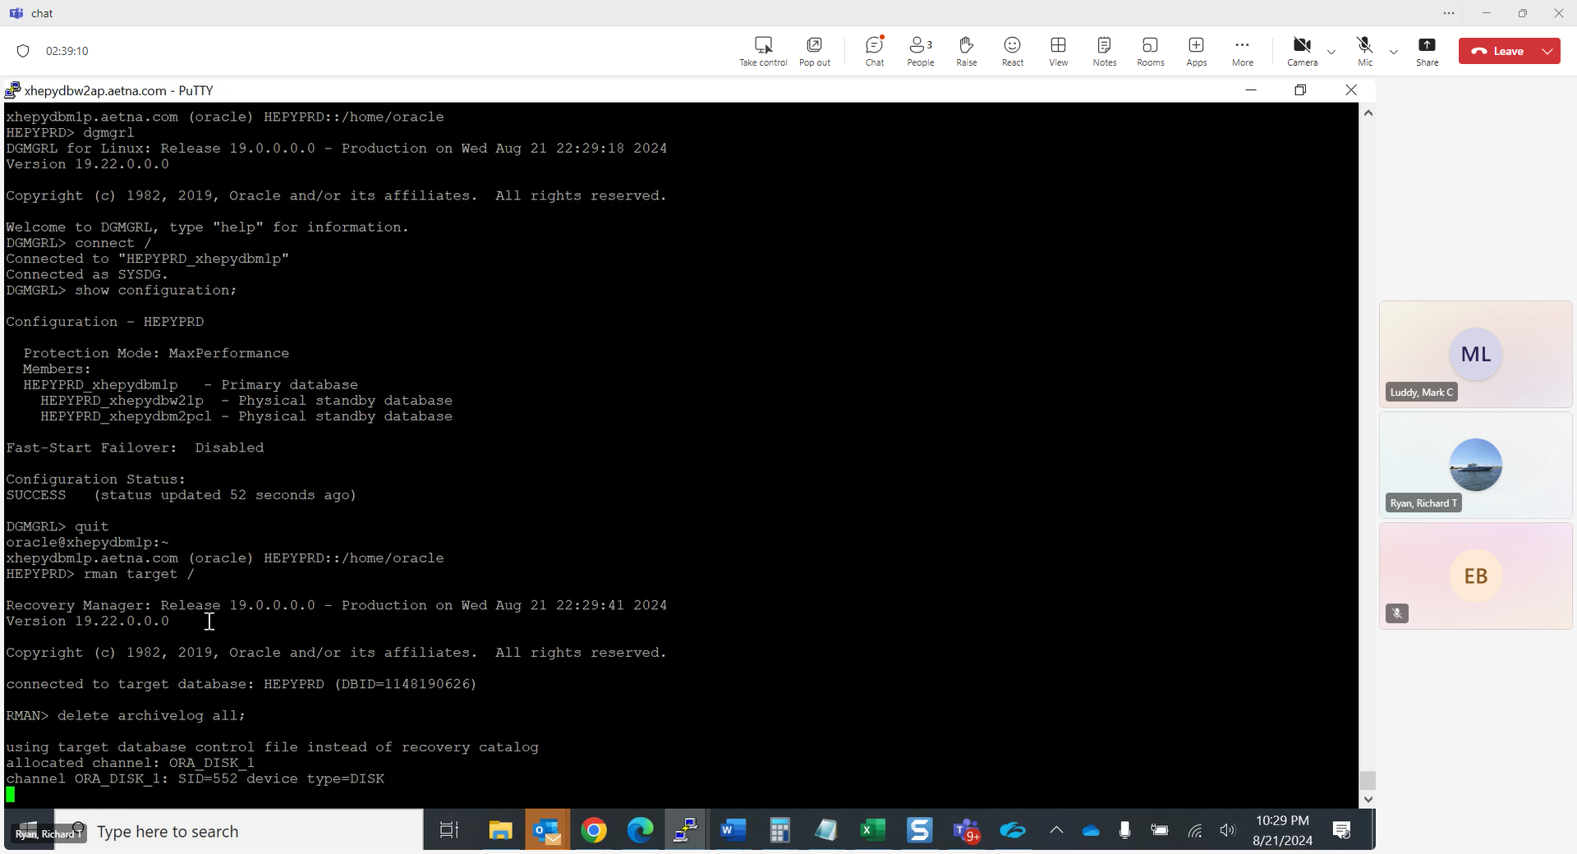

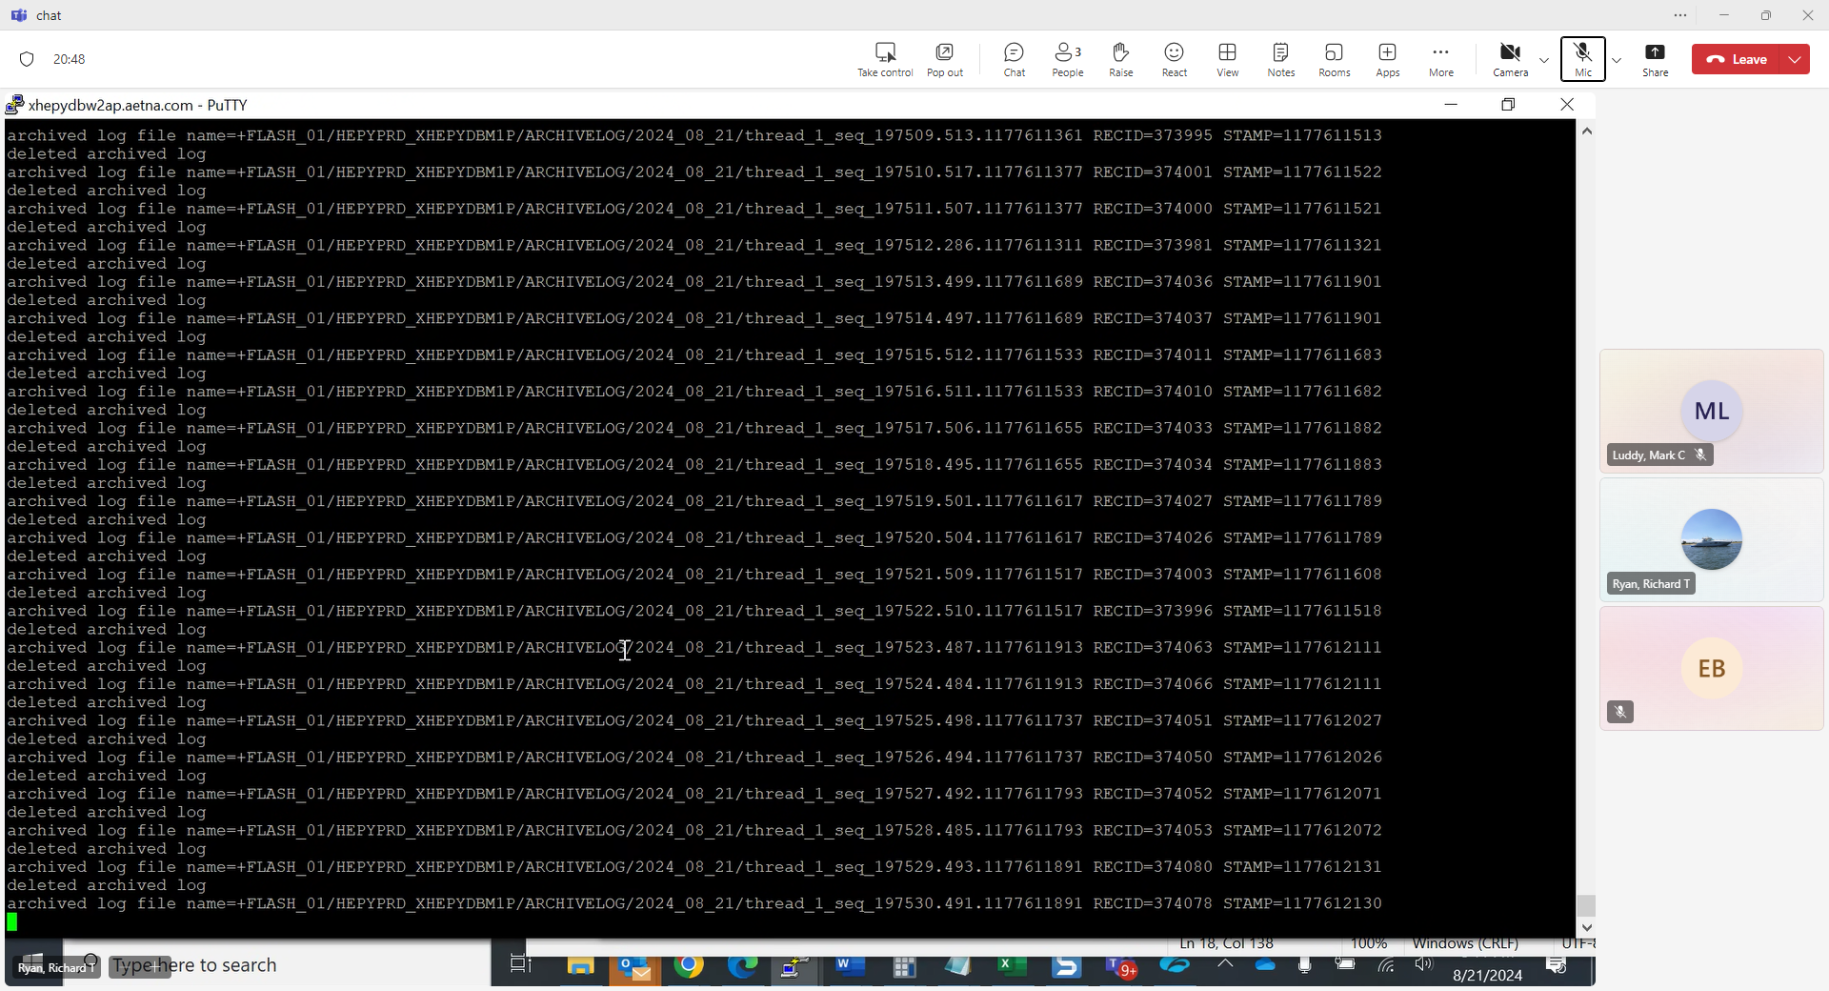

**# Below example how to manually run archivelog backup command (we had to run it to clear up FLASH_01 space)**

**rmanc**

**backup archivelog all delete input;**

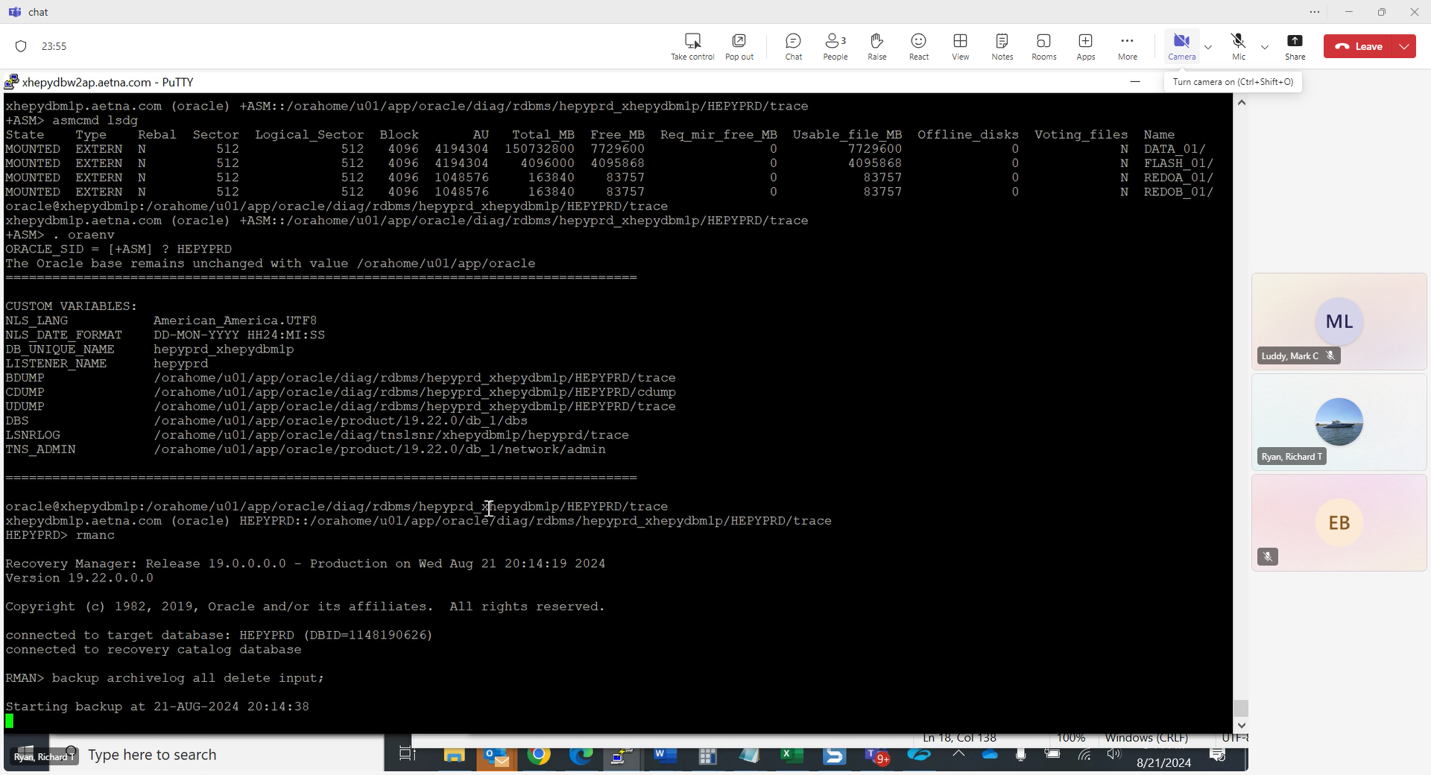

**#Steps below on Primary on how to add Standby to it manually**

**From Primary**

1. **#set $DEST variable**





1. **Add database to broker configuration.**





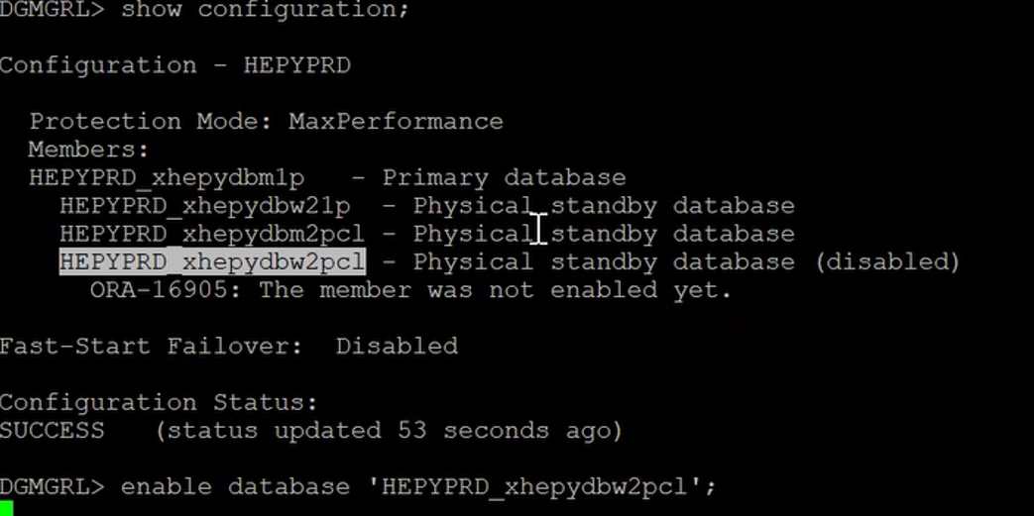

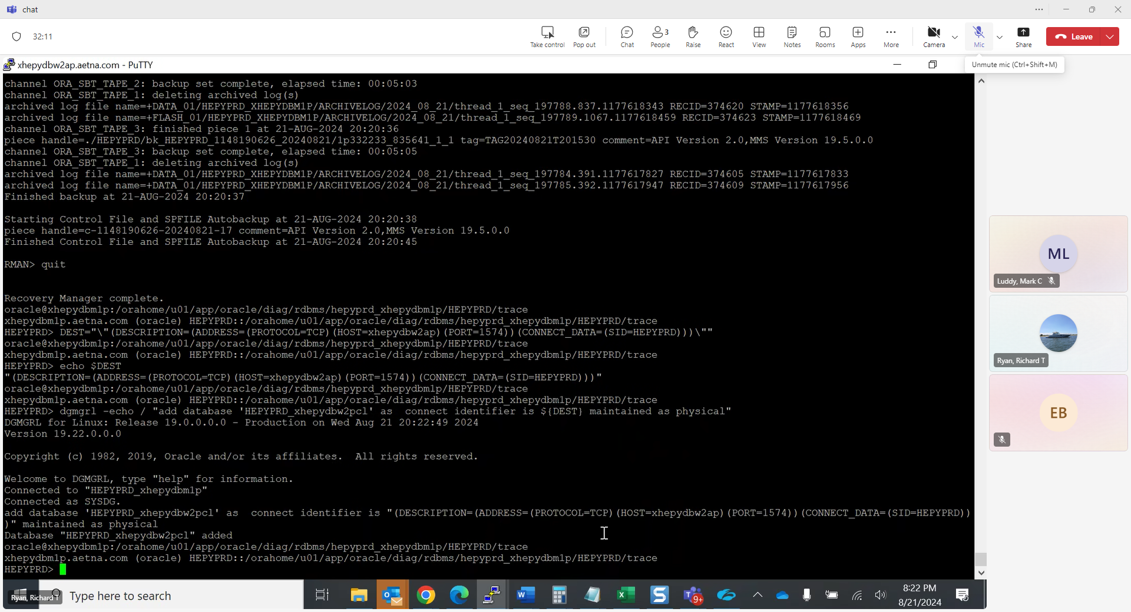

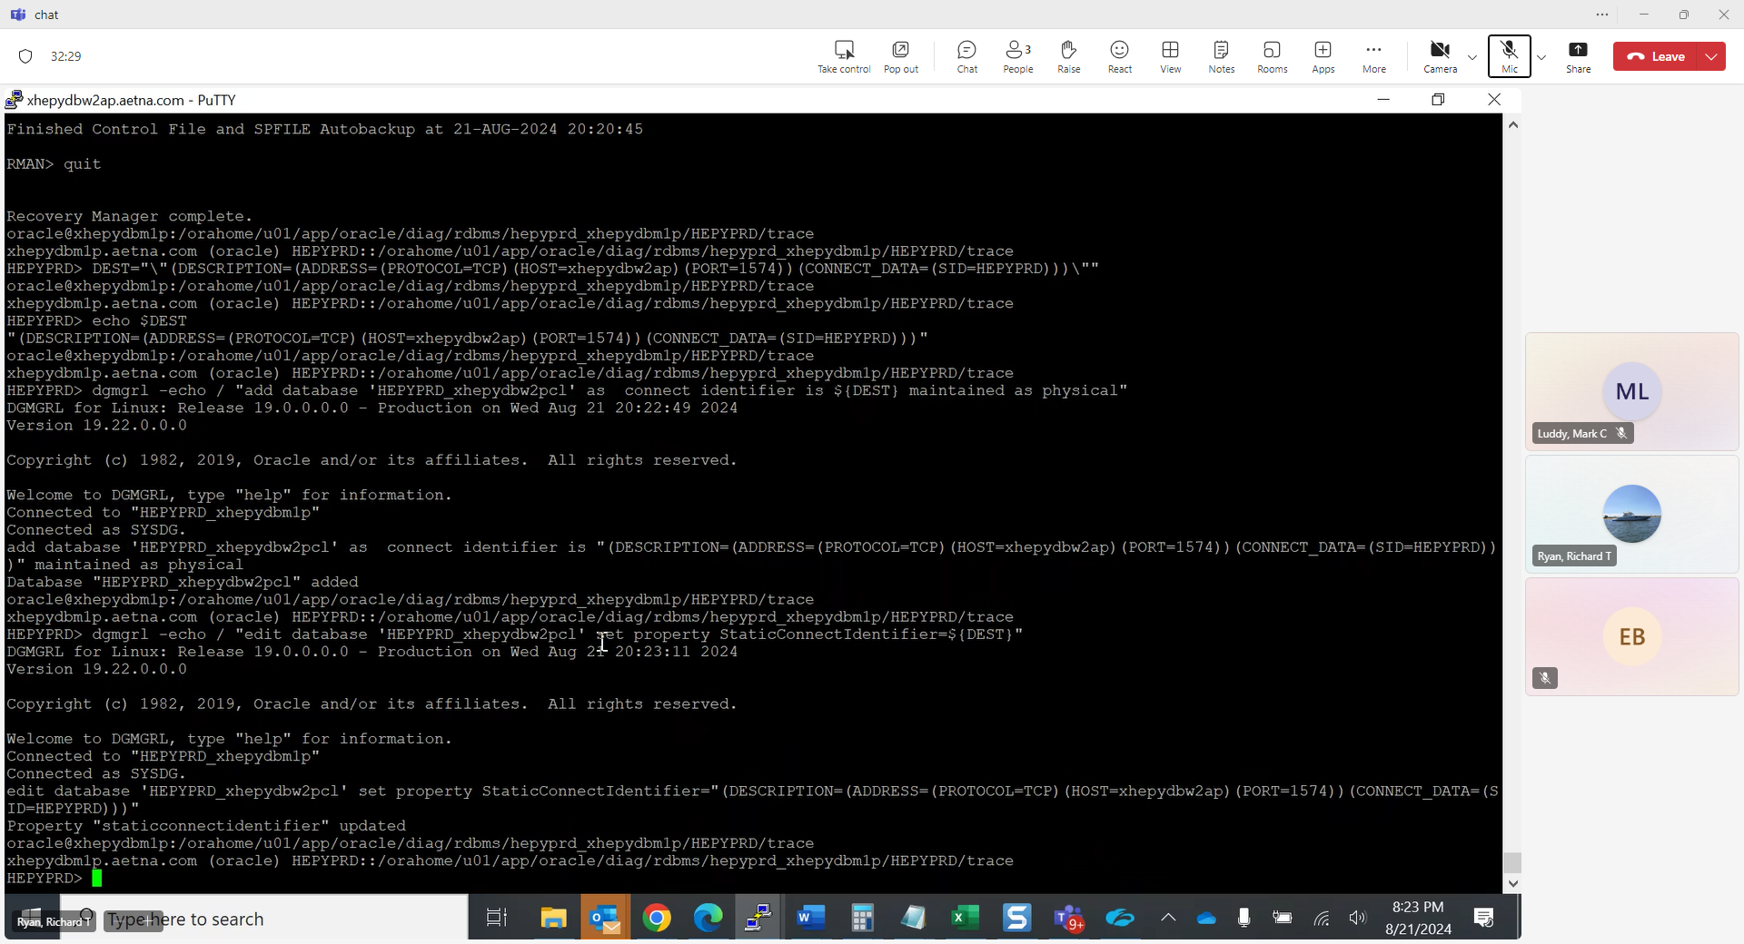

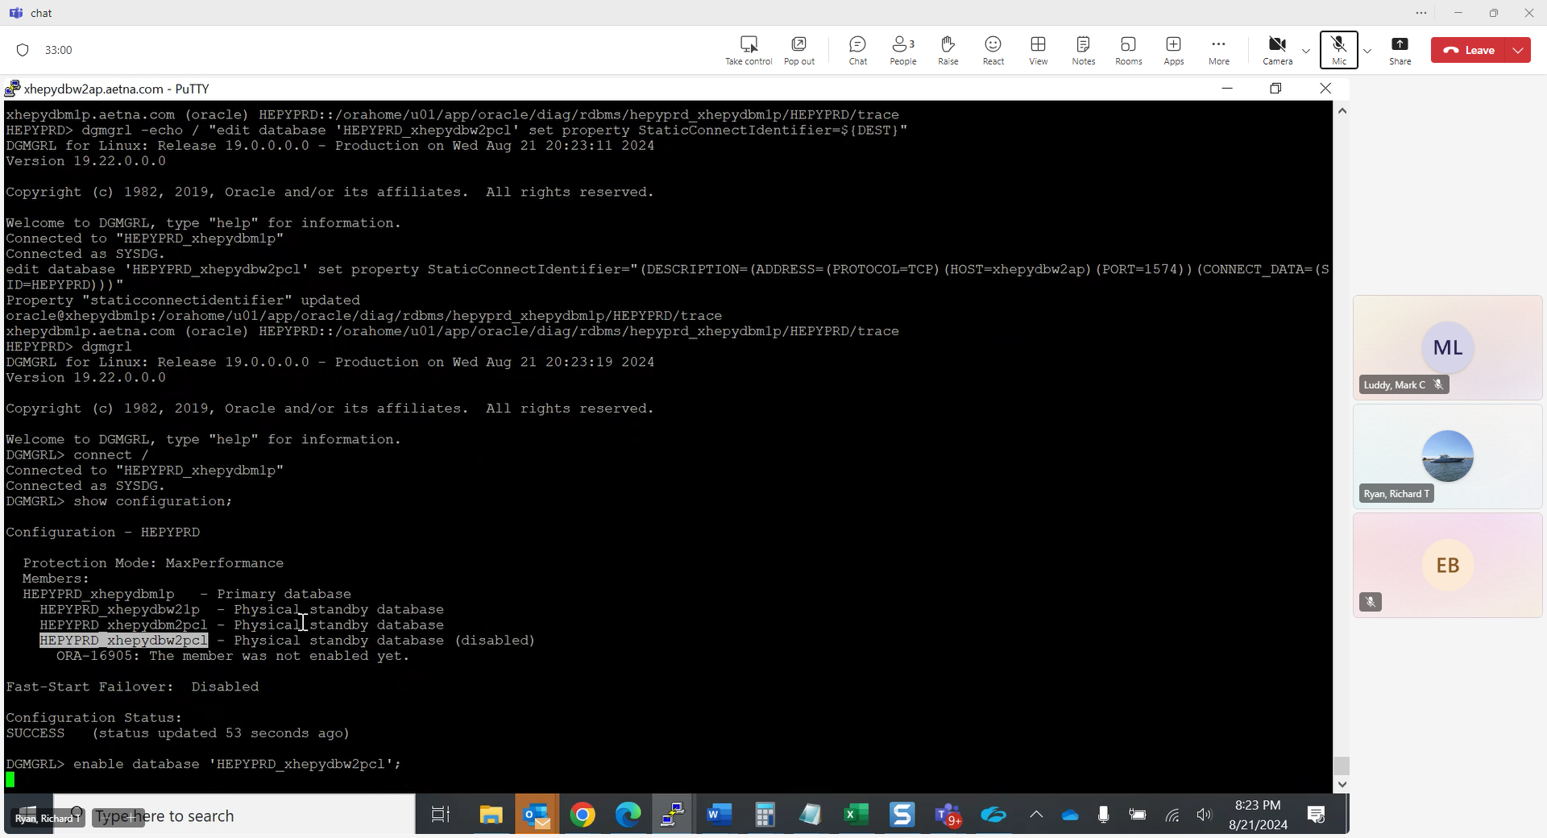

**\*\*\*\*\* Tom’s email few days later \*\*\*\***

**Roll Forward Physical Standby Using RMAN Incremental Backup in Single Command (Doc ID 2431311.1)**

When you encountered the gap, could you not have run the following from the standby?

RECOVER STANDBY DATABASE FROM SERVICE HEPYPRD_xhepydbm1p;  (Have to stop redo apply (MRP) first.)

alter database recover managed standby database cancel;

or

dgmgrl /

edit database 'DBNAME_SERVERNAME' set state=apply-off;

I’ve used this in the past when I had encountered a large gap, worked nicely.

**!!! Note: attempted to use during HECVQA2 issue and ran into issues below. End up dropping Standby and re creating.**

**Starting restore at 15-OCT-2024 08:13:47**

**RMAN-00571: ===========================================================**

**RMAN-00569: =============== ERROR MESSAGE STACK FOLLOWS ===============**

**RMAN-00571: ===========================================================**

**RMAN-03002: failure of recover command at 10/15/2024 08:13:47**

**RMAN-03015: error occurred in stored script Memory Script**

**ORA-19554: error allocating device, device type: SBT_TAPE, device name:**

**ORA-27211: Failed to load Media Management Library**

**Additional information: 4176**